* Android external storage

Android external storage can be used to write and save data, read configuration files etc.

External storage such as SD card can also store application data, there’s no security enforced upon files you save to the external storage. In general there are two types of External Storage:

* **Primary External Storage**: In built shared storage which is “accessible by the user by plugging in a USB cable and mounting it as a drive on a host computer”. Example: When we say Nexus 5 32 GB.
* **Secondary External Storage**: Removable storage. Example: SD Card

All applications can read and write files placed on the external storage and the user can remove them. We need to check if the SD card is available and if we can write to it. Once we’ve checked that the external storage is available only then we can write to it else the save button would be disabled.

[**Android External Storage Example Project Structure**](https://www.digitalocean.com/community/tutorials/android-external-storage-read-write-save-file#android-external-storage-example-project-structure)

[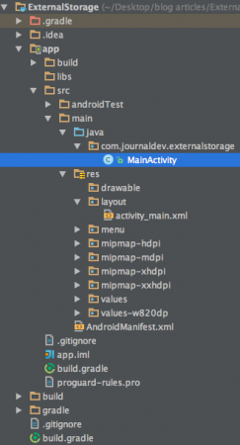](https://journaldev.nyc3.cdn.digitaloceanspaces.com/2015/10/android-external-storage-project-view.png)

Firstly, we need to make sure that the application has permission to read and write data to the users SD card, so lets open up the AndroidManifest.xml and add the following permissions:

<uses-permission android:name="android.permission.WRITE_EXTERNAL_STORAGE"/>

<uses-permission android:name="android.permission.READ_EXTERNAL_STORAGE"/>

Also, external storage may be tied up by the user having mounted it as a USB storage device. So we need to check if the external storage is available and is not read only.

if (!isExternalStorageAvailable() || isExternalStorageReadOnly()) {

saveButton.setEnabled(false);

}

private static boolean isExternalStorageReadOnly() {

String extStorageState = Environment.getExternalStorageState();

if (Environment.MEDIA_MOUNTED_READ_ONLY.equals(extStorageState)) {

return true;

}

return false;

}

private static boolean isExternalStorageAvailable() {

String extStorageState = Environment.getExternalStorageState();

if (Environment.MEDIA_MOUNTED.equals(extStorageState)) {

return true;

}

return false;

} getExternalStorageState() is a static method of Environment to determine if external storage is presently available or not. As you can see if the condition is false we’ve disabled the save button.

Here apart from the save and read from external storage buttons we display the response of saving/reading to/from an external storage in a textview unlike in the previous tutorial where [android toast](https://www.digitalocean.com/community/tutorials/android-spinner-drop-down-list) was displayed.